Tugas Portfolio

* Website Travel
* Link Github : https://github.com/muhamadrizkihasan/portfolio-react
* Home

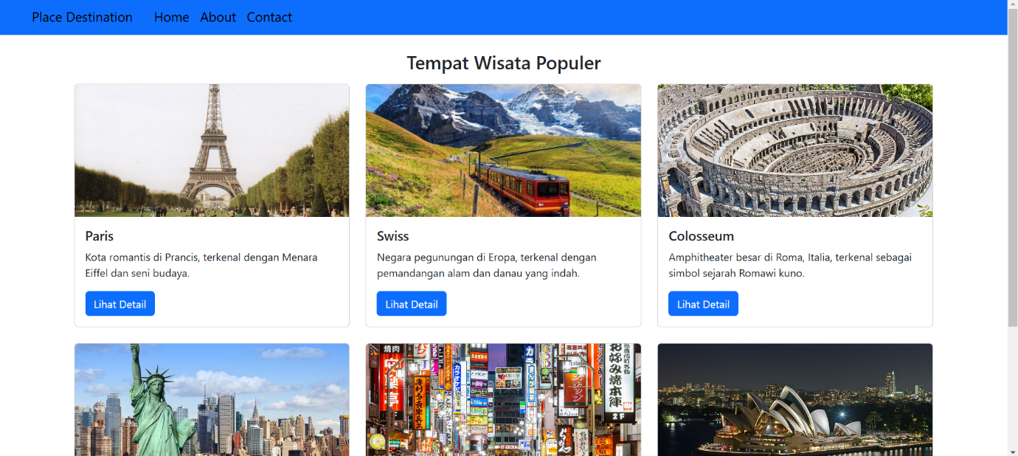

* Detail

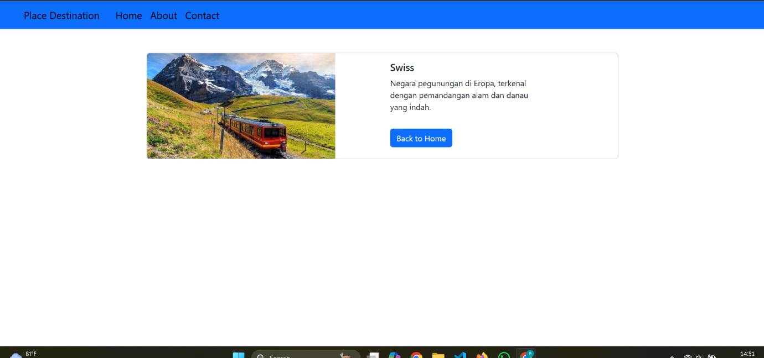

* About

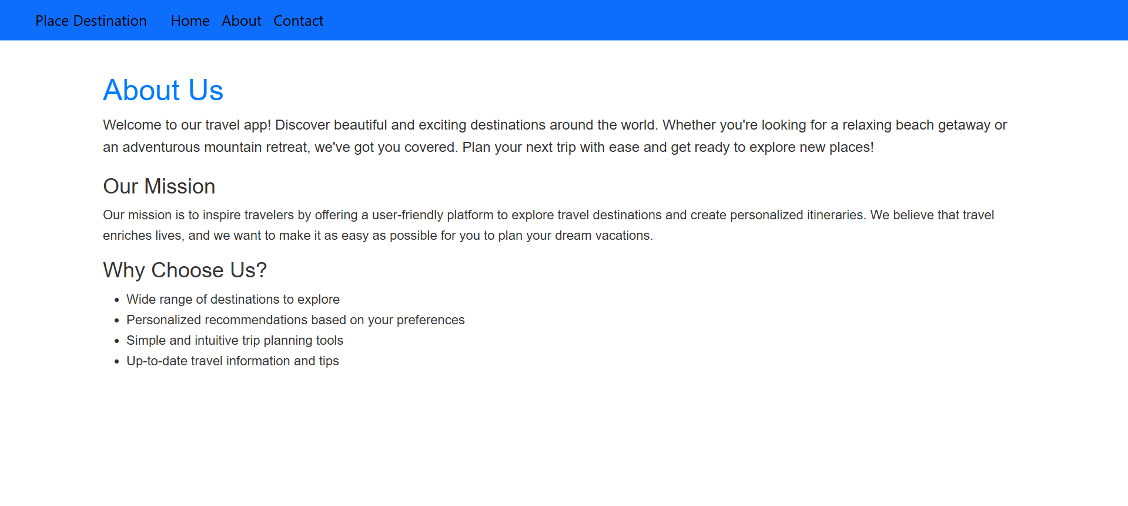

* Contact

